**Circuit and System-I**

**LAB # 05**



**Spring 2022**

Submitted by: Ali Asghar

Registration No.: **21PWCSE2059**

Class Section: **C**

“On my honor, as student of University of Engineering and Technology, I have neither given nor received unauthorized assistance on this academic work.”

Student Signature: ______________

Submitted to:

**Engr. Faiz Ullah**

19 May, 2022

Department of Computer Systems Engineering

**ASSESSMENT RUBRICS LAB # 5**

**Verification of KCL using PSPICE**

|  |  |  |  |  |
| --- | --- | --- | --- | --- |
| **LAB REPORT ASSESSMENT** | | | | |
| **Criteria** | **Excellent** | **Average** | **Nill** | **Marks Obtained** |
| 1. **Objectives of Lab** | All objectives of lab are properly covered  [Marks 0.5] | Objectives of lab are partially covered  [Marks 0.25] | Objectives of lab are not shown  [Marks 0] |  |
| 1. **Kirchhoff’s Current Law**   **(Statement, Mathematical Expression, Circuit Diagram)** | Correct KCL statement and mathematical expression is written. Circuit diagram shown is correct and properly labeled  [Marks 1] | KCL statement or mathematical expression or circuit diagram is missing or circuit diagram is not properly labeled  [Marks 0.5] | |  |
| 1. **PSPICE**   **Simulator** | Brief introduction of PSPICE simulator  [Marks 1] | Brief introduction of PSPICE simulator  Is not shown  [Marks 0] | |  |
| 1. **Procedure** | All experimental steps are shown in detail  [Marks 1.5] | Some of the experimental steps are missing [Marks 1] | Experimental steps are missing  [Marks 0] |  |
| 1. **Observations & Calculations** | All experimental results are completely shown in form of table for both cases of using same resistors and for different resistors with varying applied source voltage  [Marks 4] | Experimental results are partially shown and some of the observations are missing  [Marks 2] | No experimental results are shown  [Marks 0] |  |
| 1. **Analysis** | Analysis and discussion about all experimental results are shown  [Marks 2] | Analysis and discussion about experimental results are partially shown  [Marks 1] | Analysis is not shown  [Marks 0] |  |
| Total Marks Obtained:__________  Instructor Signature: ______________________ | | | | |

**Title:**

Verification of **KCL** using **PSPICE**

**Objectives** :

* To find current in the wire using PSPICE software.
* To be able to use PSPICE.
* To understand KCL and it’s uses.

**Kirchhoff’s current law (KCL):**

In 1847, Gustav Robert Kirchhoff, a professor at the University of Berlin, formulated two important laws that provide the foundation for analysis of electric circuits. These laws are referred to as Kirchhoff’s current law (KCL) and Kirchhoff’s voltage law (KVL) in his honor. Kirchhoff’s laws are a consequence of conservation of charge and conservation of energy. Kirchhoff’s current law states that the algebraic sum of the currents entering any node is identically zero for all instants of time.

**STATEMENT:**

The algebraic sum of the currents into a node at any instant is zero.*.*

**MATHEMATICAL FORM :**

∑I = 0

**Circuit Diagram :**

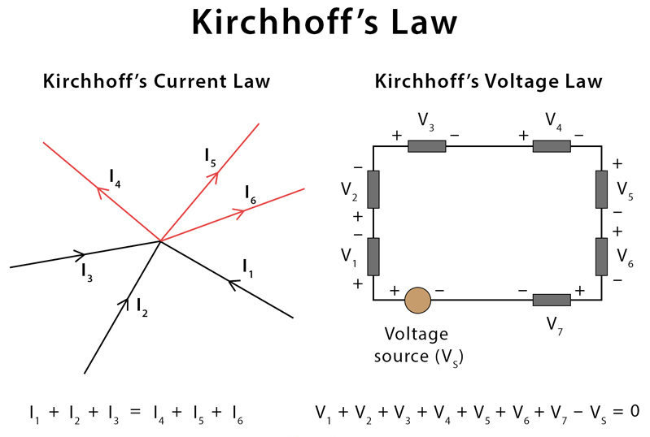

**PSPICE:**

**Intoduction:**

**PSpice** is a SPICE analog circuit and digital logic simulation software that runs on personal computers, hence the first letter "P" in its name. It was developed by MicroSim and is used in electronic design automation. MicroSim was bought by OrCAD which was subsequently purchased by Cadence Design Systems. The name is an acronym for Personal Simulation Program with Integrated Circuit Emphasis. Today it has evolved into an analog mixed signal simulator.

OR

“PSPICE is a circuit analysis tool that allows the user to simulate a circuit and extract key voltages and currents.”

**STEPS**:

* Go to start menu and search for Schematics.
* Select “Menu Draw”. Get new parts.
* Then click the “Libraries” button (You will get a window named as Library Brower).
* Go to “Part Browser Basic”, input the device name in the “Part Name” or select it in the bottom catalog.
* Click “Place” button, then you can put the selected devices into you schematic.
* Connect the devices you have put onto your schematic, use menu “Draw Wire“, your cursor would change to be a pencil.
* Check your circuit carefully, compare it with the circuit in your Lab Pak. Check the name and value of every device.
* Save your schematic.
* Use the menu “Analysis Setup” to set up the simulation condition.
* 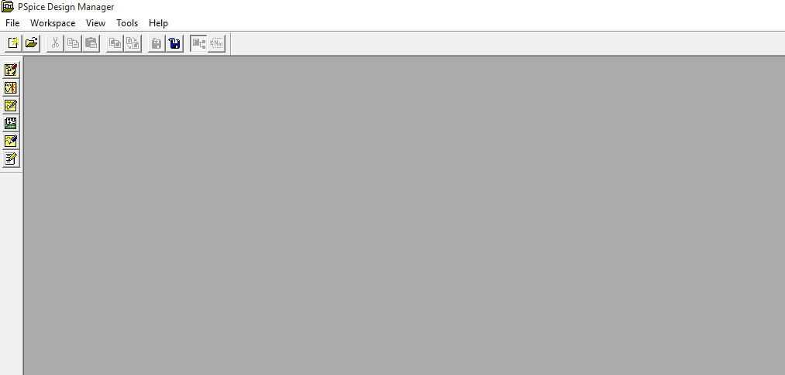Use the menu “Analysis Simulation”.

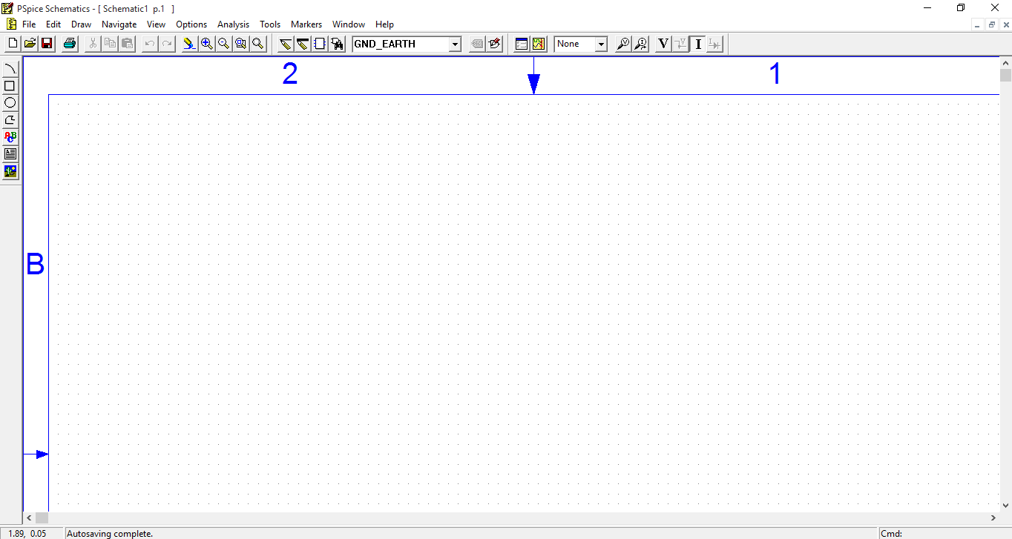

R1 = 2k, R2 = 5k and R3 = 14k

**Case 1:**

For voltage of 5v.

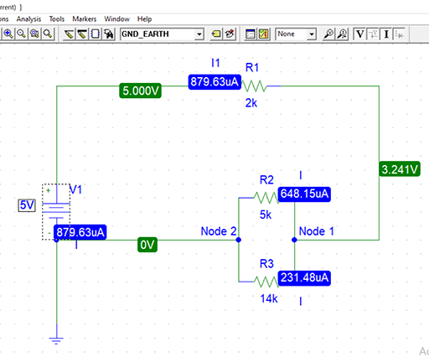

**Case 2:**

Voltage of 10v.

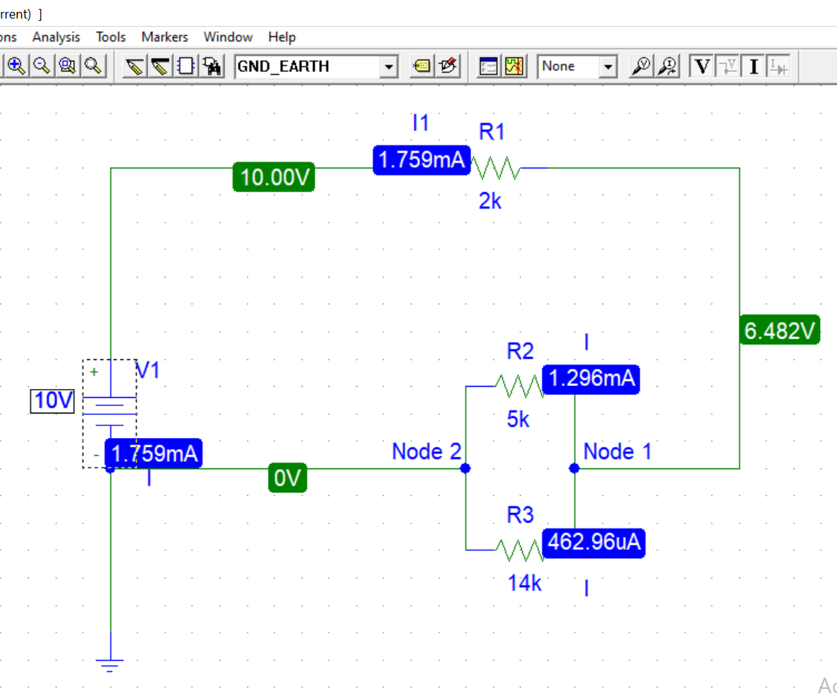

**Case 3:**

Voltage of 15v.

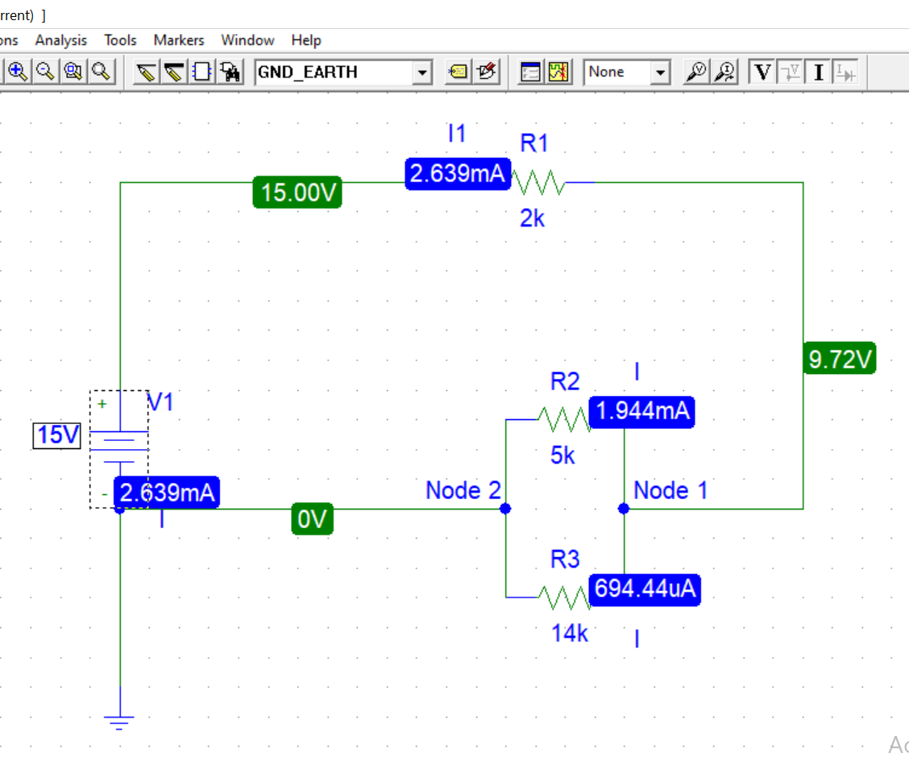

**Case 4:**

Voltage of 20v.

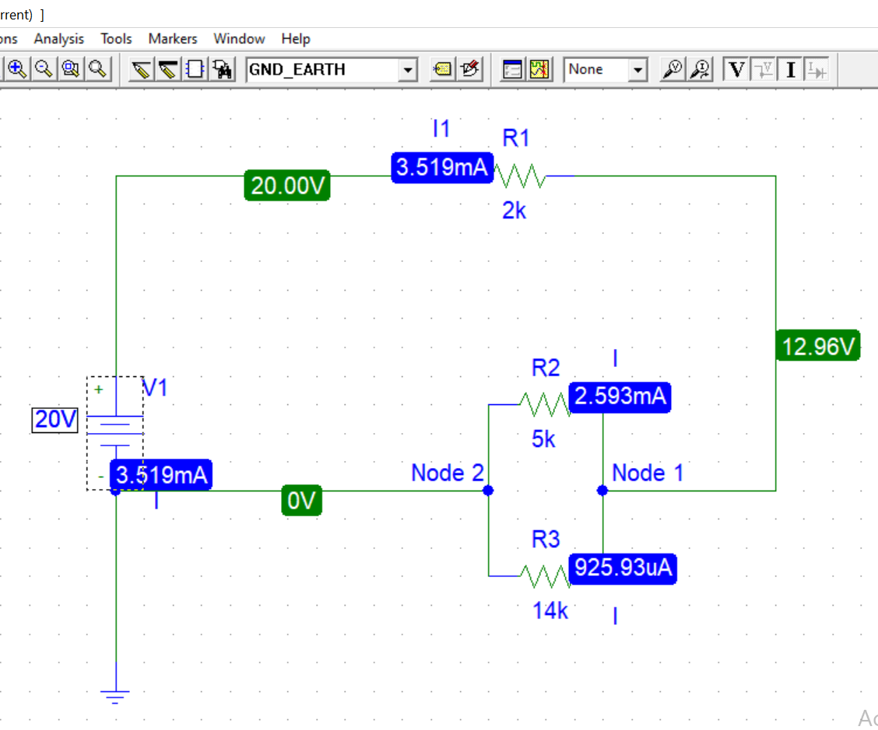

**Case 5:**

Voltage of 25v.

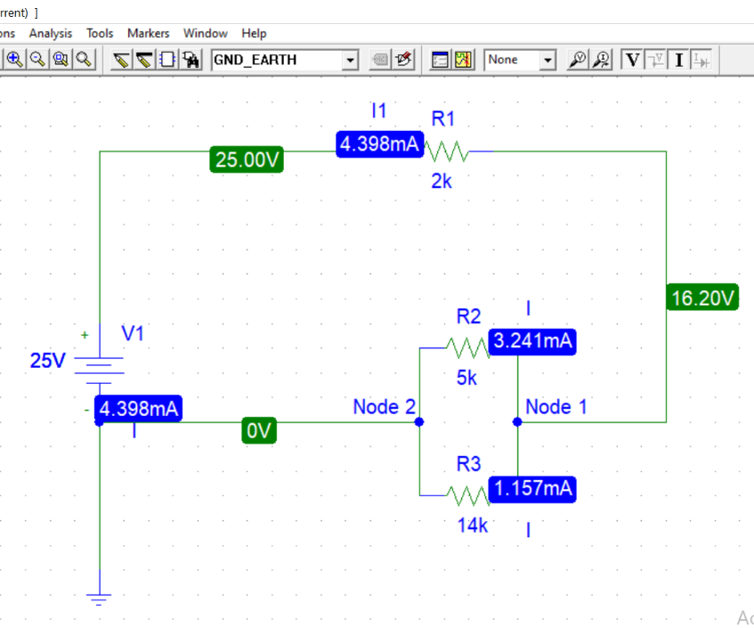

**Case 6:**

Voltage of 30v.

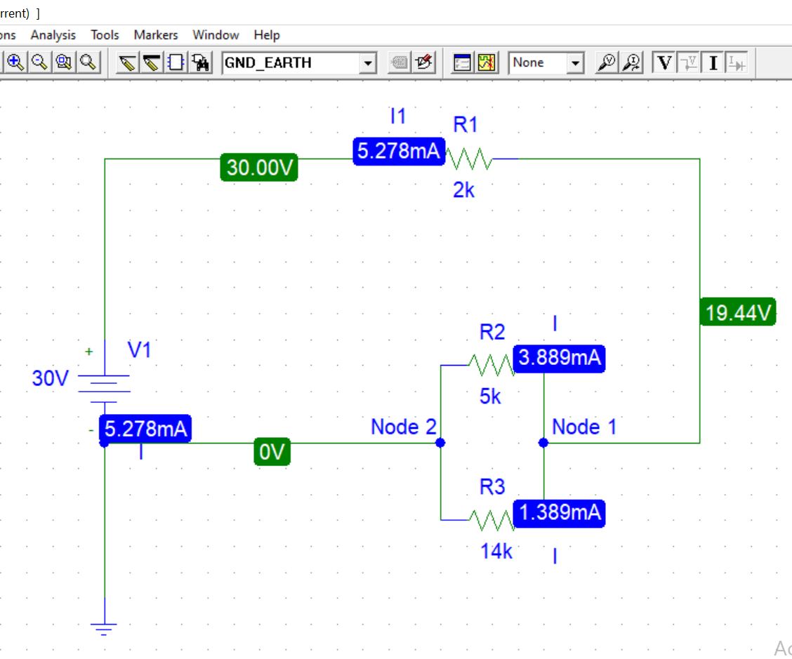

**OBSERVATION:**

|  |  |  |  |  |  |  |  |
| --- | --- | --- | --- | --- | --- | --- | --- |
| S.No. | V | I1 | I2 | I3 | I4 = I2+I3 | Node1 | Node2 |
| 1 | 5 | 879.63 µA | 648.15 µA | 231.48µA | 879.63µA | 879.63µA = 648.15 µA + 231.48µA | 648.15 µA + 231.48µA = 879.63µA |
| 2 | 10 | 1.759 mA | 1.296 mA | 462.96 µA | 2.222mA | 2.222mA = 1.296 mA + 462.96 µA | 1.296 mA + 462.96 µA = 2.222mA |
| 3 | 15 | 2.639 mA | 1.944 mA | 694.44 µA | 2.639 mA | 2.639 mA = 1.944 mA + 694.44 µA | 1.944 mA + 694.44 µA = 2.639 mA |
| 4 | 20 | 3.519 mA | 2.593 mA | 925.93 µA | 3.519 mA | 3.519 mA = 2.593 mA + 925.93 µA | 2.593 mA + 925.93 µA = 3.519 mA |
| 5 | 25 | 4.398 mA | 3.241 mA | 1.157 mA | 4.398 mA | 4.398 mA = 3.241 mA + 1.157 mA | 3.241 mA + 1.157 mA = 4.398 mA |
| 6 | 30 | 5.278 mA | 3.889 mA | 1.389 mA | 5.278 mA | 5.278 mA = 3.889 mA + 1.389 mA | 3.889 mA + 1.389 mA = 5.278 mA |